STUDENT UNIFORM AND
PERSONAL PRESENTATION POLICY
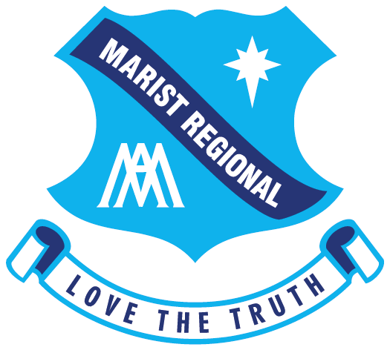

RELATED DOCUMENTS

This Guideline should be considered in conjunction with the following related documents:
Policies and  Procedures | Archdiocese of Hobart Anti-Discrimination, Bullying and Harassment Policy  Archdiocese of Hobart Protecting Children and Vulnerable Adult Policy  Archdiocese of Hobart Privacy Policy  TCEC Anti-Discrimination, Harassment and Bullying Policy  TCEC Code of Conduct  TCEC Complaints Processing Policy
Applicable Laws | All laws in connection with the carrying out of work or the Workplace including:  Australian Education Regulation 2013  Disability Discrimination Act 1992  Disability Standards for Education 2005  Privacy Act 1988  Australian Privacy Principles (APP)
Accountability | Catholic Education Tasmania (CET)  Australian Institute for Teaching and School Leadership (AITSL)

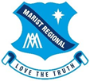
VERSION  NUMBER: | 1.0 | APPROVED BY: | Principal
RESPONSIBLE/  BREACHES REPORTABLE TO: | Deputy Principal Pastoral Wellbeing | DATE APPROVED: | 2020
 |  | SCHEDULED  REVIEW DATE: | 2023

RATIONALE

The Marist Regional College uniform is an integral and important part of our tradition and identity. As a College community, we anticipate and expect our students will wear their uniform with pride. In wearing the uniform correctly, students express a respect for themselves, each other and the wider College community as a whole.
Parents, teachers and all members of our College play a role in ensuring we maintain a culture of equality, engagement and achievement. Collectively, we play a critical role in supporting our young people to attend to uniform expectations, thereby supporting broader attempts to build social cohesion across the College.
The Marist Regional College values call us to be a Catholic community in which all people are treated equally. Our College uniform promotes consistency and inclusiveness for all students and their families. It tells of who we are past, present and future. It represents our Mission, our Values, and our long-standing commitment as a place of learning and teaching in the Marist and Mercy traditions.

PURPOSE

- To outline the expectations and responsibilities regarding the wearing of the student uniform at the College, so there is no uncertainty in what is required.
- To ensure that all students of the College wear the academic and sporting uniforms correctly.
- To reinforce with our students that a pride in their own appearance as a student of Marist Regional College, instils recognition of themselves as an integral and valued part of the College community, and gives a strong sense of their identity as representatives of the College.

SCOPE

All uniform items, except for shoes and belts, are to be purchased from the College Uniform Shop.
Summer Uniform (Term 1 and Term 4)
Boys:  - College Blazer  - College Open-Neck, Short Sleeved  White Pinstripe Shirt  - College Navy Blue Shorts  - College Navy Blue Long Trousers  - College Jumper  - College Marle Blue Socks  - Black Leather Shoes  - School Hat/Cap/Bucket Hat – optional  - Belt (optional – plain black, simple silver buckle) | Girls:  - College Blazer  - College Summer Dress  - College Open-Neck, Short Sleeved White Pinstripe Shirt  - College Navy Blue Winter Skirt  - College Navy Blue Shorts (optional)  - College Navy Blue Long Trousers  - College Jumper  - College Blue Socks  - Black Leather Shoes  - School Hat/Cap/Bucket Hat – optional

Winter Uniform (Term 2 and Term 3)
Due to the climate, winter uniform may be worn throughout the year. If done so, it must be worn in its entirety. It is also the formal academic dress uniform for official functions of the College.

Boys:  - College Blazer  - College Long Sleeved, White Pinstripe Shirt and College Tie (or Senior College Tie)  - College Navy Blue Long Trousers  - College Jumper  - Black or Navy Socks (not Summer socks)  - Black Leather Shoes  - Belt (optional–plain black, simple silver buckle) | Girls:  - College Blazer  - College Long Sleeved, White Pinstripe Shirt and College Tie (or Senior College Tie)  - College Navy Blue Skirt  - College Jumper  - Navy Blue Tights  - College Navy Blue Long Trousers (Optional)  - Black Leather Shoes

Plain navy gloves and scarf may be worn during Winter. No emblems, adornments or additional colours.
Shoes
Shoes must be plain black, polished, leather school shoes. Enclosed leather shoes, that cover the feet, are essential for reasons of health and safety. Shoes must have a low/medium heel, not flat or with a wedge or platform heel. Suede, boots, skate/sneaker, ballet slipper style shoes and loafers are not permitted.
Please see images of acceptable shoes at the end of this policy. If parents are unsure, please ask prior to an expensive purchase of an incorrect shoe.

School Bag
A standard College Bag is compulsory and available from the Uniform Shop.

Physical Education and Sports Uniform
The following uniform is compulsory for Physical Education classes.

- College polo top  - College navy sports jacket  (optional)  - College navy blue shorts  - College navy track suit pants (optional)  - College beanie (optional)  - College hoodie (optional) | One or more of the following bottoms:  - College navy blue skort or College navy blue shorts  - College navy blue tights – long or below the knee  - College navy track suit pants
- Sports Footwear (shoes and socks) should be appropriate to the activity or sport.

- When representing the College in carnivals or team sports, the full College sports uniform must be worn. If not wearing the full College sports uniform, students must wear the academic uniform and change into the sports uniform at the event.

- When competing for the College in swimming events, students must wear College bathers. When competing for the College in other sports, school skirts and pants or shorts must be worn with the appropriate tops and footwear, unless the rules and traditions of the sport require something different.

Individual Sports Uniform available from the College Uniform Shop:
- Football Jumper  - Basketball Singlet  - Bathers | - Sky/Navy Football/Soccer/Hockey Socks  - White Sports Socks  - Navy Football Shorts
UNIFORM SHOP
The Uniform Shop is open: Tuesdays: 9.00am – 4.00pm
Thursdays: 9.00am – 4.00pm
Phone during opening times on 6432 7662.
The shop is closed on Student Free days and public holidays.

GUIDELINES FOR CASUAL DAYS
On designated casual clothes days, students must wear clothing, which respects their own dignity and that of others in the College community. The guidelines below reflect the required standard.
- Not to be worn: unsuitable clothing including exposed shoulders (small width straps), low-cut, see-through or overly short garments (including tops, shorts and skirts); clothing printed with offensive statements or slogans;
- Jewellery, hair and make-up should not be excessive. Long hair should be tied back for some practical lessons, as per the regular expectations.
- Closed shoes only must be worn. Thongs, open sandals and slip on shoes are not appropriate for reasons of safety.

EXPECTATIONS
Blazer: The College blazer is a compulsory part of the uniform. It must be worn to and from school every day and to all assemblies and official College events. During the school day the blazer need not be worn.
Academic Uniform: The formal academic uniform must be worn to and from school every day. Students must change into and out of the sports uniform before and at the end of the timetabled HPE lessons and/or any lesson when the sports uniform is required. Students representing the College at sporting events may be permitted to wear the appropriate representative sports uniform, as advised by the College.
Any time that a student is wearing the College uniform, it must be worn fully and correctly, this includes before school and after school, including when in town.
Dresses and skirts: Must be an appropriate length. A good guide is one hand width above the knee. Any dresses or skirts deemed to be too short will be required to be adjusted in a timely fashion.
Winter warmth: On particularly cold days, students are encouraged to wear thermal-wear under their uniform for added warmth. This should not be visible. Jackets, including puffer jackets, hoodies and any other outerwear that does not conform with the uniform, must not be worn.
College Beanie: Beanies are not part of our everyday school uniform, therefore should not be worn during the course of the normal school day, including recess and lunch, unless students are at an event where HPE uniform or out of school uniform is permissible to wear eg. Sports days, sporting events, extra curricula activities which are outdoors.
College Sports Jacket/Hoodie
The College sports jacket/hoodie is an optional part of the sports uniform and is not an alternative to the College blazer. The hoodie must not be worn during any part of the school day unless it is for HPE or co-curricular activities where sports uniform is permitted to be worn. The spray jacket may be worn over the blazer coming to and from school, only when it is raining, and must be removed when the student is at school.
The old-style spray jacket (navy blue/light blue/azure blue) must not be worn.

Marking of Clothes: All items of clothing must be clearly marked. (Woven names are recommended or name printed clearly with a permanent marking pen.)

Hair: Hair must be neat and tidy at all times and in a style appropriate to wearing with the College uniform. Extreme hair styles are not permitted (mullets are to be no longer than collar length). Dreadlocks are not permitted. Hair is to be worn off the face. In some subjects it is a requirement that long hair is tied up with an elastic band. Hair adornments are to be navy blue, plain and not showy. Hair may be dyed, however, unnatural colours are not acceptable.
Yrs 7-10 students are to be clean shaven. Senior College students may have a neatly trimmed beard or moustache.

Make-up: Make-up is not encouraged; however, if worn, is limited to minimal foundation e.g. tinted moisturiser and/or mascara. It should not be obvious. Eyeliner, eyeshadow, blush and lipstick are not acceptable.
Coloured nail polish may not be worn. Clear varnish or a simple French polish are acceptable.
Any coloured nail polish applied for College dinners or formals, must be removed within one week of the event.
Visible tattoos are not permitted and must always be fully covered, including sporting events, such as athletics and swimming carnivals and school events, such as camps, retreats and formals.
Jewellery: The following items of jewellery are allowed:
- A simple wristwatch
- One simple neck chain (worn under the clothing)
- One plain, simple, gold or silver bracelet
- One plain, simple, gold or silver ring
Piercings:
Ears piercings: The only visible ear piercings allowed, are a maximum of two pairs of small, plain, silver or gold 10mm sleepers, or 5mm in diameter (maximum) gold or silver studs, diamante or pearl earrings – worn in the lobe and one in the helix (upper ear).
See images for clarification.
Any ear piercings in locations other than the lobe are not to be visible, including covered with tape. Hair must always cover these piercings. If this is not possible, these piercings must not be worn at school.
Facial piercings: No facial piercings are permitted, including tongue and nose piercings, this includes clear, taped or make-up covered piercings.
Body piercings: Body piercings, including naval piercings are not to be visible. This includes at sporting events, such as athletics and swimming carnivals.
OUT OF UNIFORM
If a student presents at school out of full, formal academic uniform, an explanatory note from a parent/guardian must be presented to the Pastoral Care Group Leader. The student will be given an exemption card to carry for that school day. Notes cannot be written for extended periods as it is expected that any uniform matters are addressed as a priority.
When a student is not able to wear the full, formal academic uniform, he/she must wear the full Sports Uniform. Casual clothes, including sports tights, other than the MRC sports tights are not allowed.
Students who do not comply with uniform expectations, including jewellery, piercings, make-up, and nails, will be issued with a letter requesting that this be corrected within a given time frame. Should this not occur, the student may be removed from classes or sent home until such time as the amendment has been made.

Shoes
- Enclosed shoes, that cover the feet, are essential for reasons of health and safety. Shoes must be plain black polished leather (examples A to F below)
- Shoes must have a low/medium heel, but not wedge or platform heel (examples A to F below).
- Suede/canvas, boots, skate/sneaker, sandshoes, ballet flats style shoes and loafers are not permitted (examples below).
- Some shoes marketed as school shoes, are not within the required style. If in doubt, please check before making a purchase.

Styles of shoes accepted:
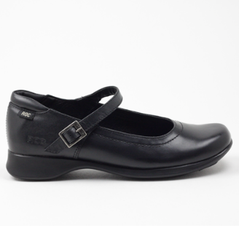
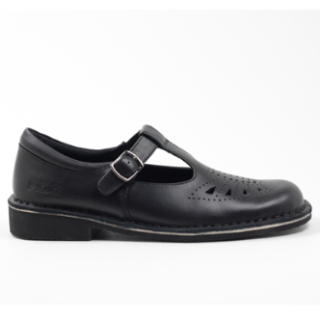
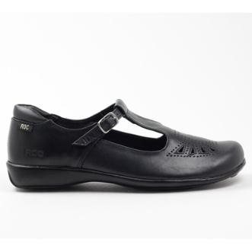
A
C
B

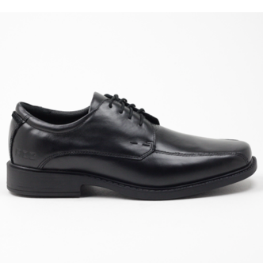
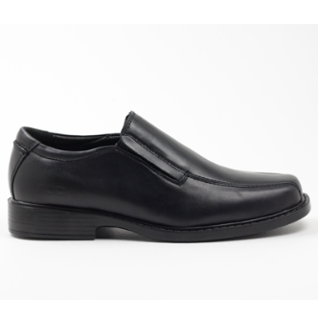
E
F
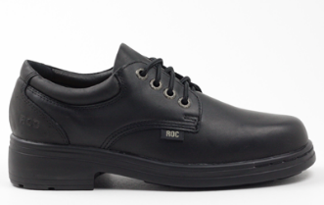
D

PLEASE SEE NEXT PAGE FOR UNACCEPTABLE SHOES

Styles of shoes NOT acceptable:

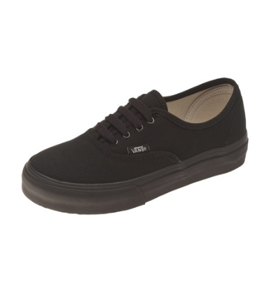
X
X
X
X

Strap too low Strap too low/no heel Ballet Flats Canvas/no heel

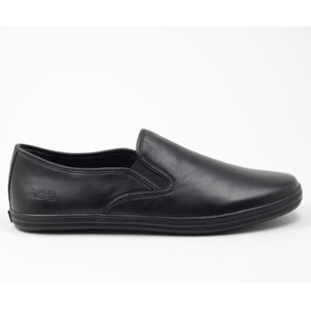
X
X
X
X

No heel No heel Canvas/no heel Canvas/no heel

PIERCINGS

Allowable Ear Piercings
The only visible piercings allowed, are a maximum of two pairs in the ear lobe and one in the upper ear (helix piercing). The following earrings are allowable:
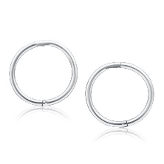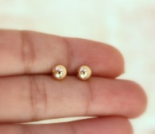
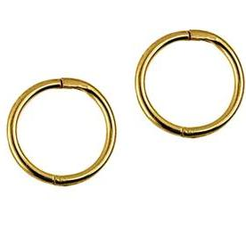
10mm (1cm) plain, silver or gold sleepers

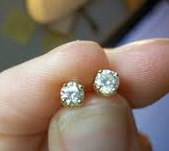
5mm (1/2 cm, maximum) in diameter - gold, silver, diamante or pearl studs.

Unacceptable Piercings
Ear Piercings
Any other ear piercings, which are not in the allowable locations eg the lobe or helix or excced the number allowed, are not to be visible, including covered with tape. Hair must cover these piercings at all times. If this is not possible, these piercings must not be worn at school.

Examples of these piercings include,
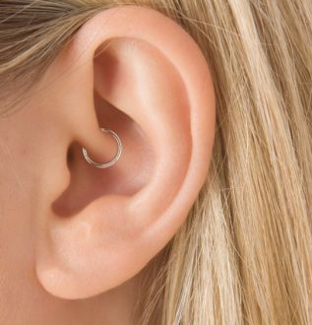
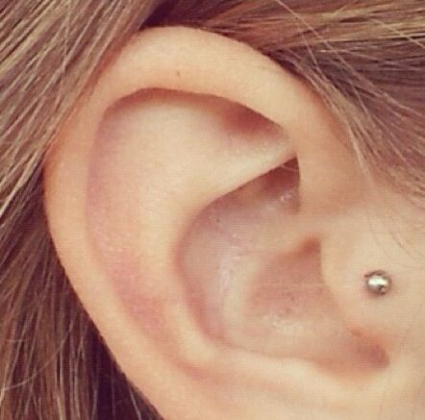
but are not limited to:

Facial Piercings
Facial piercings are NOT permitted, including tongue and nose piercings, this includes clear, taped or make-up covered piercings.

Examples of these piercings include, but not limited to:

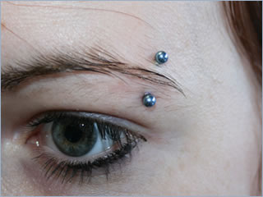
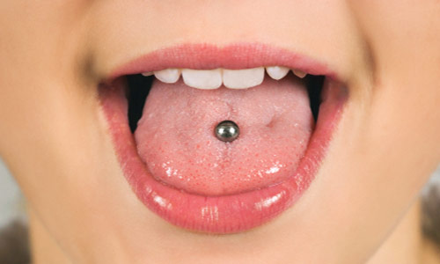
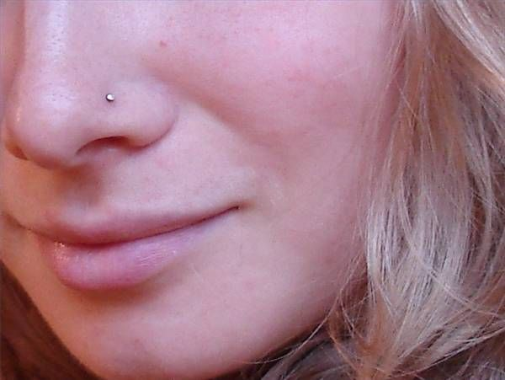

Body Piercings
Body piercings, including naval piercings are not to be visible. This includes at sporting events, such as athletics and swimming carnivals.

